FactFinder

**Justice League**

**May 2024**

**Step-to-Step Guide**

**User Manual**

**Table of Contents**

**Introduction…………………………2**

**Getting Started……………………..3**

**1.Login the application…………...4**

**2.Signing up to the application….5**

**3.Verify New page………………….6**

**4.Create Summary…………………7**

**5.Search History page…………….8**

**6.Blog page…………………………9**

**7.New post page……………………9-10**

**8.About Us page…………………..11**

**9.Team page……………………….12**

**10.Chat page……………………….13**

**11.Contact Us page……………….14**

**Introduction**

**Fact Finder is a web app designed to combat online misinformation by differentiating between fake and real news. Additionally, it can create a summary of the news.​ For anyone concerned about online misinformation and facing time constraints for reading news articles.​who upload the news article the Fact Finder web app is a web app that use machine learning and deep learning algorithms that can detect misinformation.​Unlike believe any information on internet.​**

**Our application verifies the authenticity of information and saves time by creating summaries of articles.​**

**2**misinformation by differen

**Getting Started**

**Welcome to the official user guide of Justice League an application to detect fake news**

**To Take hands-on experience check on this link**

[**https://main--factfinder.netlify.app/**](https://main--factfinder.netlify.app/)

**3**

**1 . Login the application**

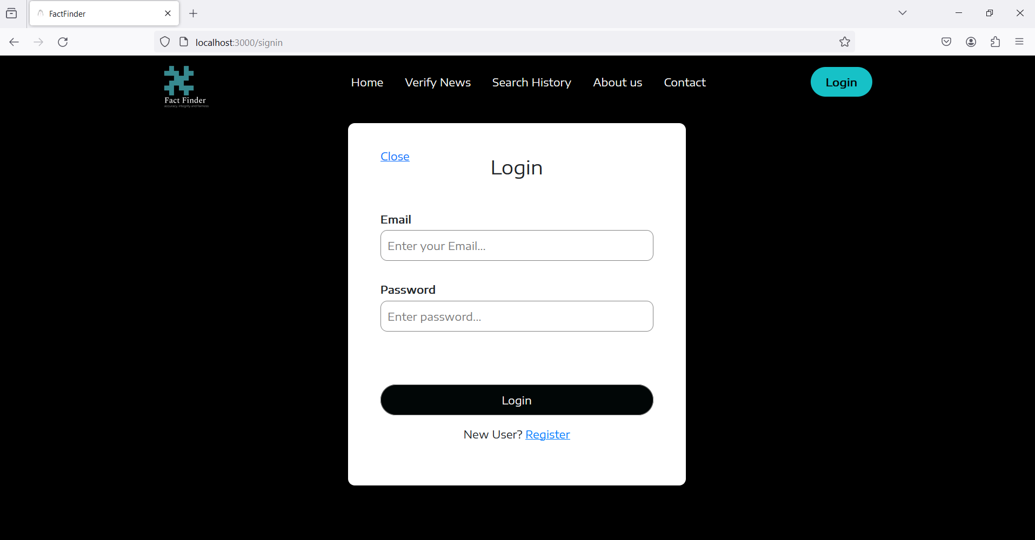

**As soon as you open the application, you are navigated to the login screen, where you can login using registered credentials.**

**If the user is not registered with the application, they can register a new account.**

**4**

**2.Signing up to the application**

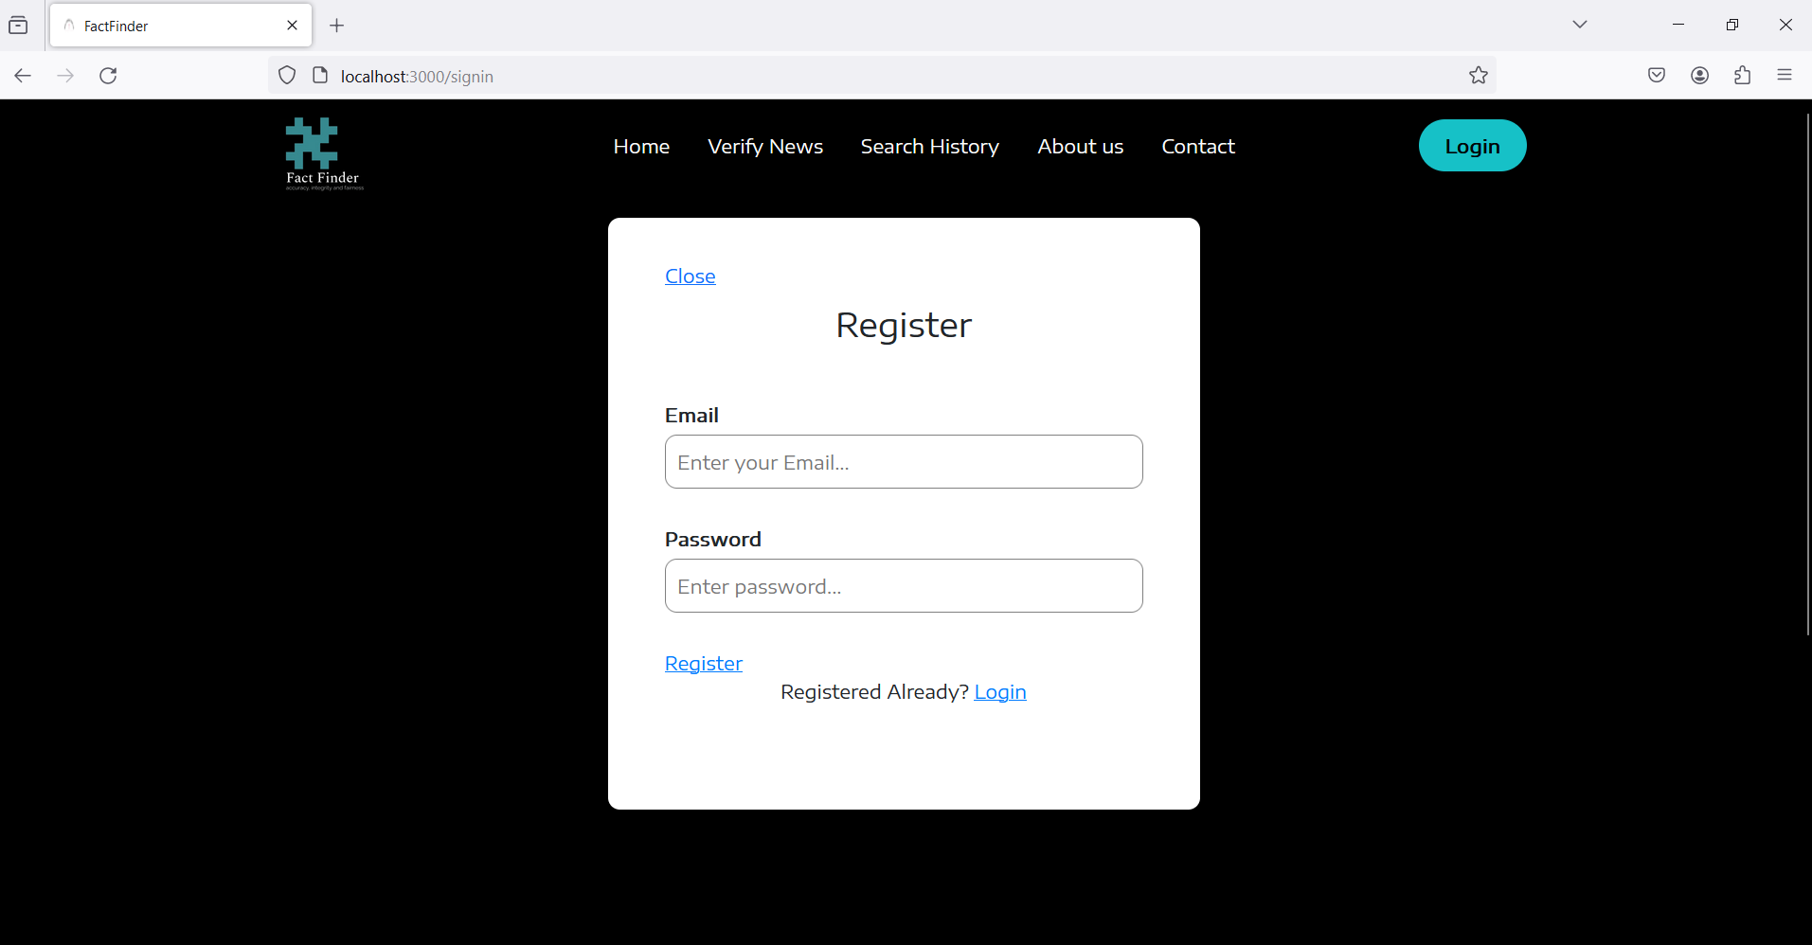

**If the user is not registered, they can easily navigate to this screen from the login screen and create a respective account by entering their Email and password. Once details are entered, the user can click on Register and finish signing up. Then the user is again navigated to the login screen.**

**5**

**Homepage**

**3. Verify News page**

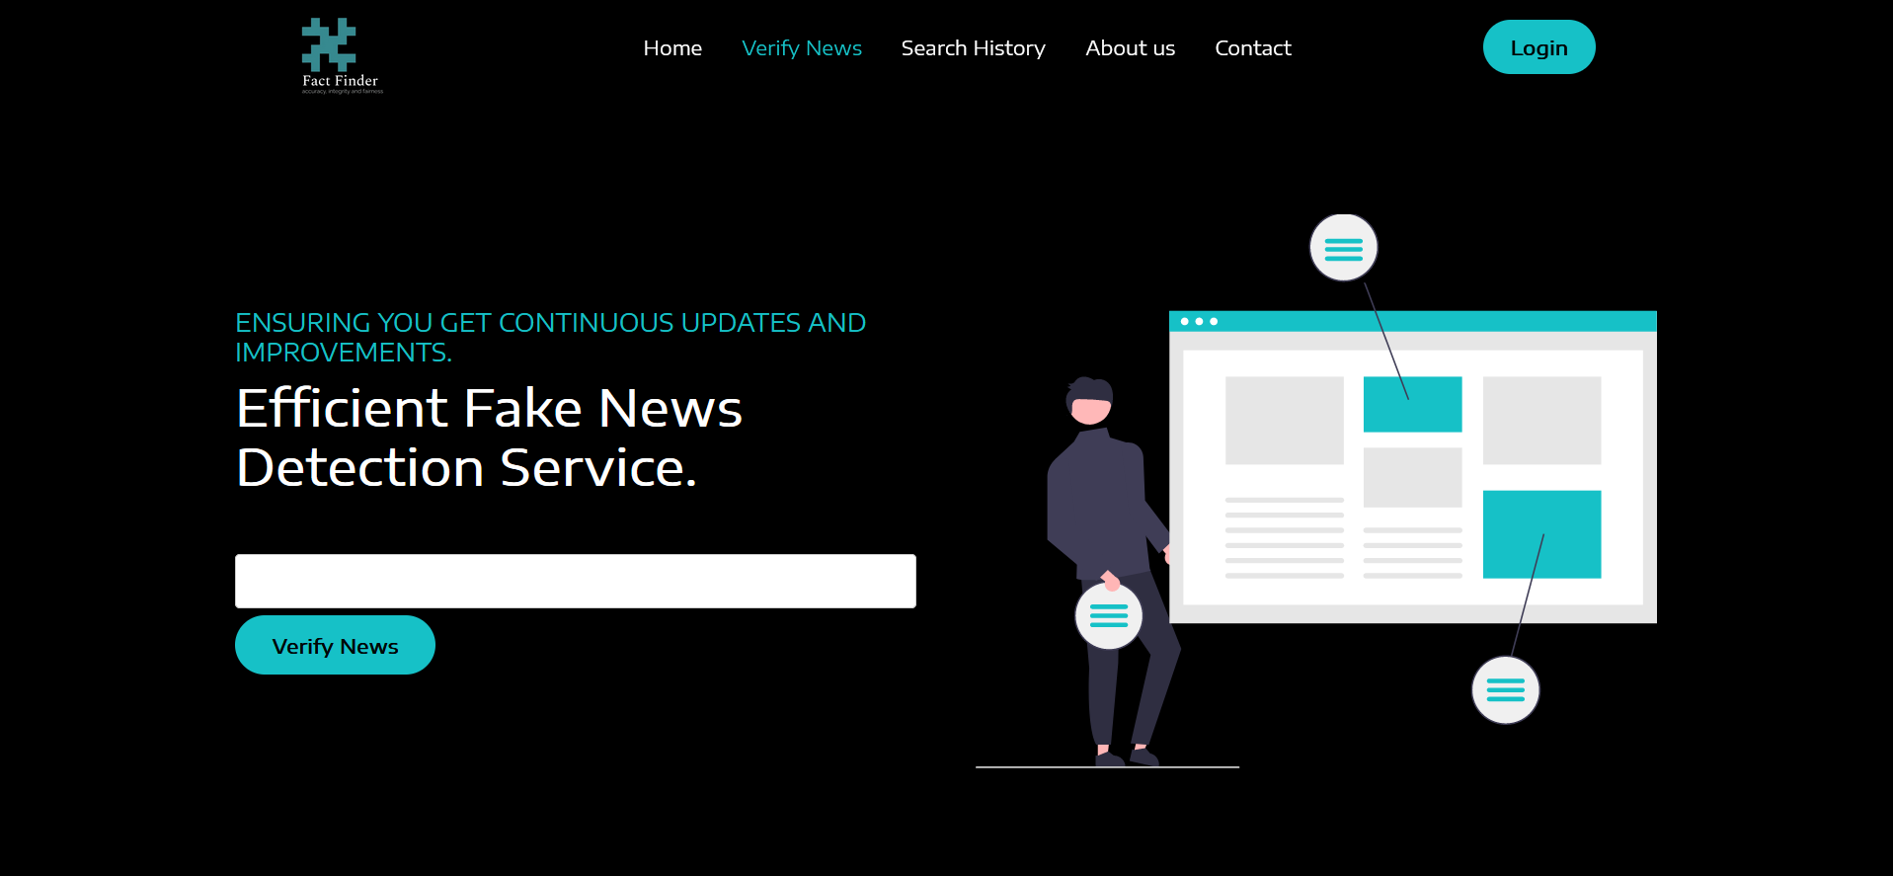

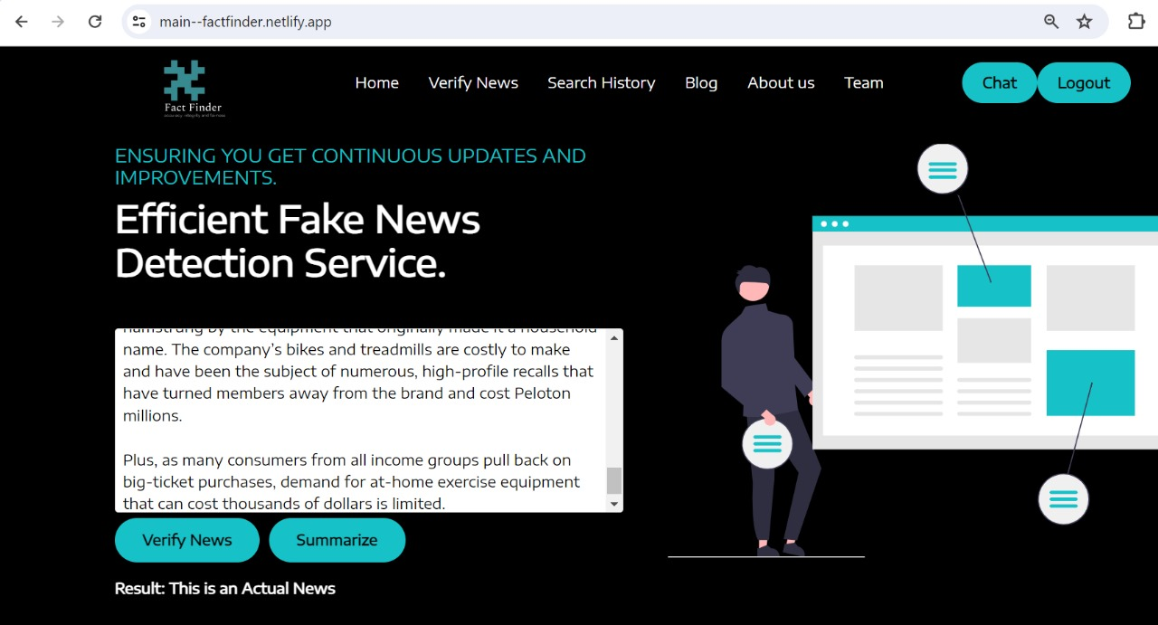

**6**

**After successfully logging into the application. You can find the verify news tab in our homepage where you can paste the news and verify it is fake or real.**

**4. Create News Summary**

**You can create news summaries by just inserting any news article.**

**7**

**5. Search History page**

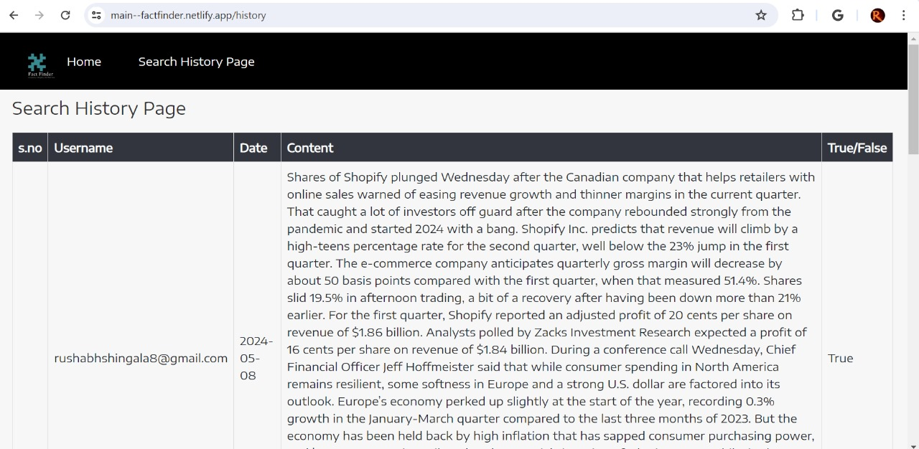

**After login the application you will see the search history page icon where you can go through the information you have checked to verify. If it is Fake news or not.**

**8**

**6. Blog page**

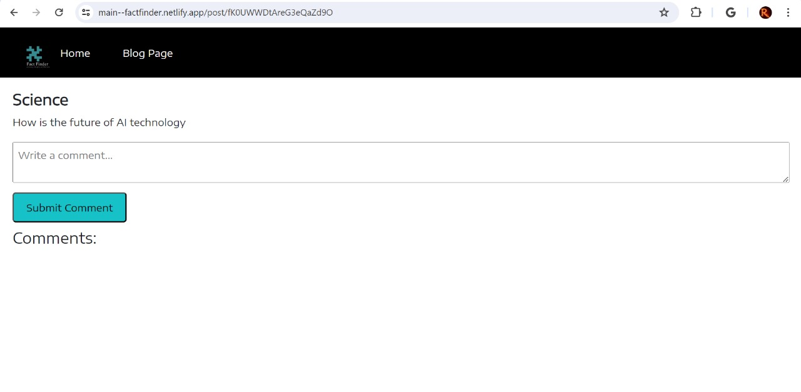

**After verifying through the search history page there is another icon called the blog page. where you can comment regarding the blog and submit through clicking the submit comment button.**

**7. New post page**

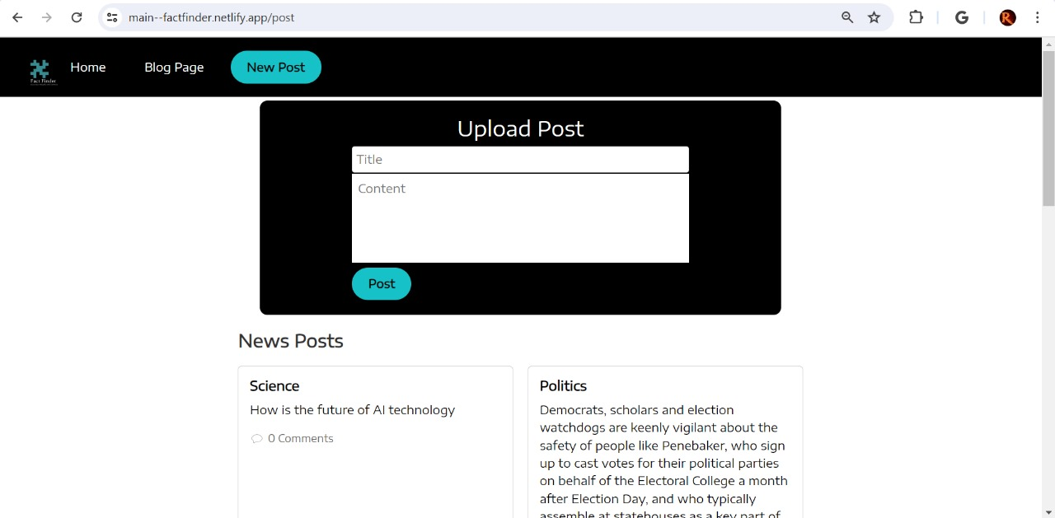

**9**

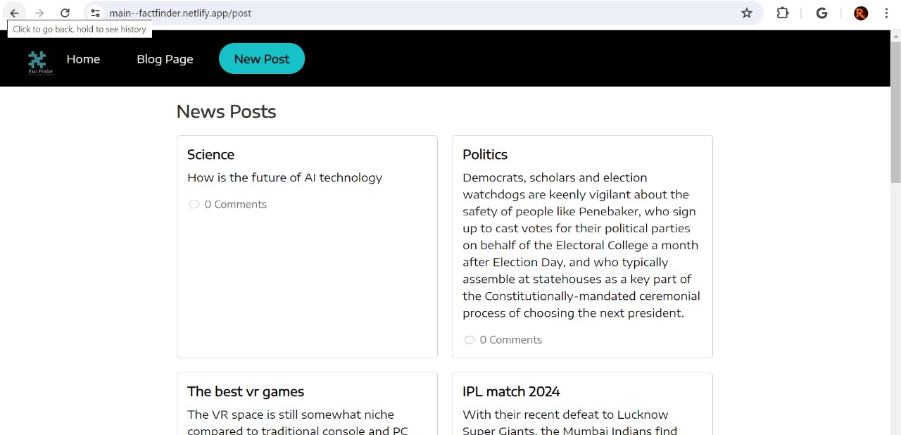

**Move forward with the New Post page Session. In this session you can create your own post by giving a suitable title and content. After clicking on the post button. Post you have created will display and viewers will comment on your post.**

**10**

**8. About Us page**

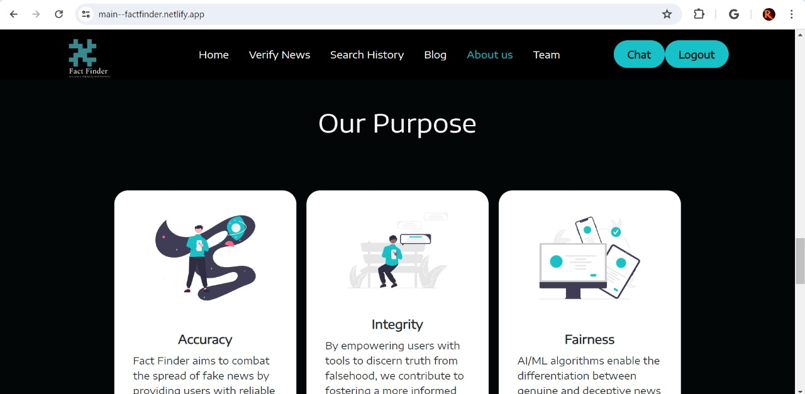

**As shown in the About us page. It describes the purpose of application with the help of accuracy, integrity and fairness we are able to achieve the motive of Fact finder.**

**11**

**9. Team page**

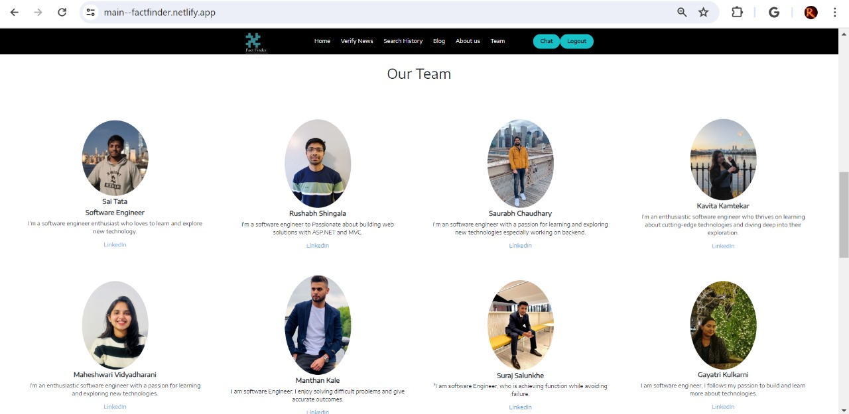

**With the help of this Awesome Team Spirit, we were able to achieve the goal of Fact Finder.**

**12**

**10. Chat page**

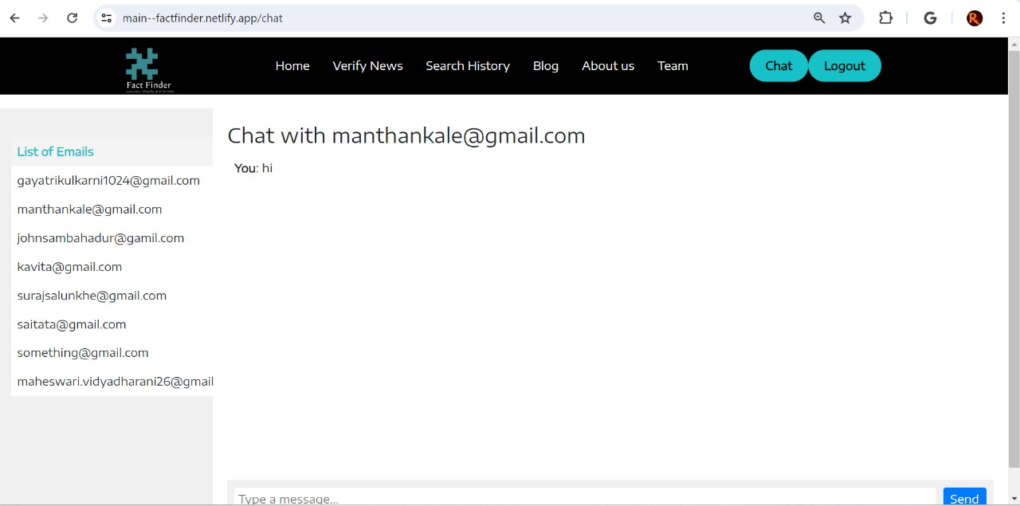

**As per this chat page section you can communicate with one or more than one peer.**

**13**

**10. Contact us page**

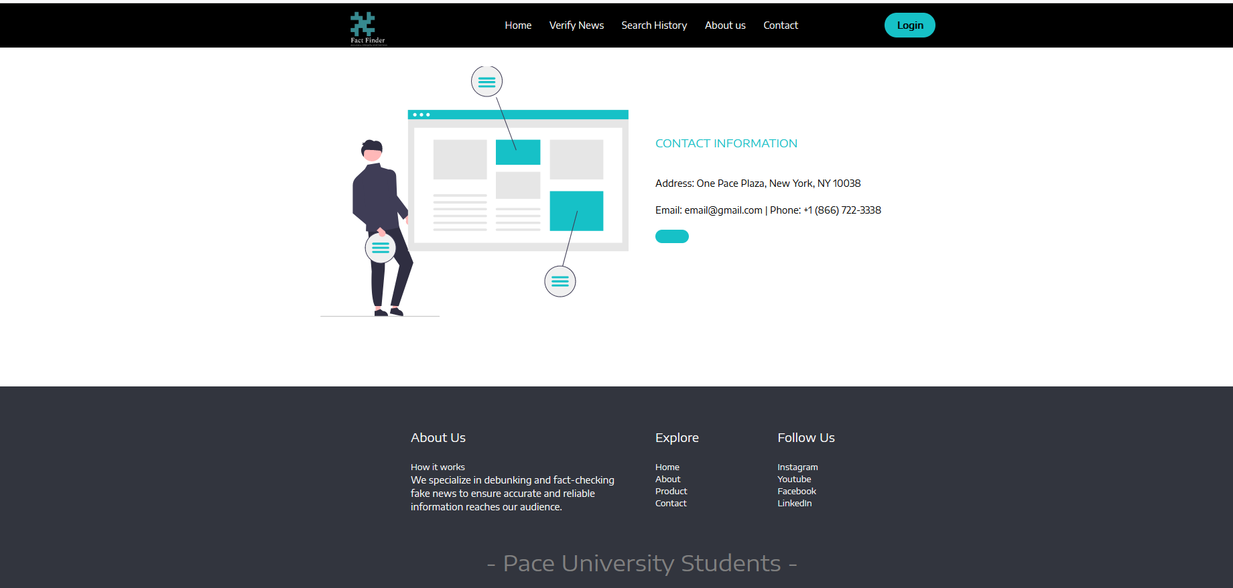

**In the Contact us page, you can follow us through social media platforms.**

**14**